Lab-2
Task 6- Docker Storage
- Demonstration of Container-Layer Data Loss:
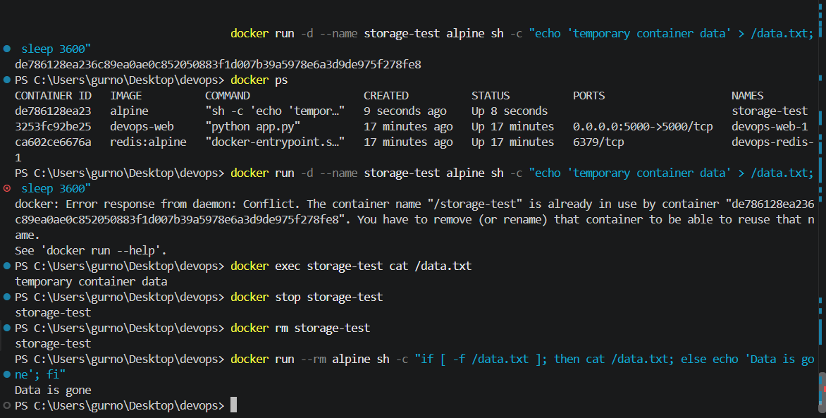
Result: The data stored in the container's writable layer was lost after the container was removed.
2) Docker Named Volume
A Docker named volume was created to demonstrate persistent storage independent of the container lifecycle.
Result: The data remained available even after the container was removed because it was stored in a Docker named volume.

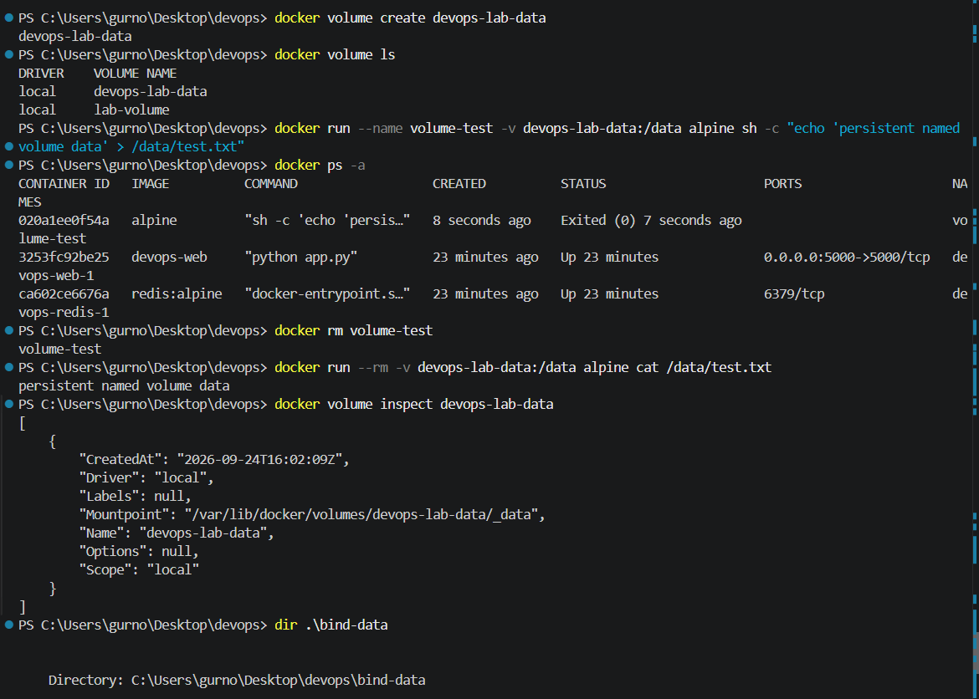
3) Docker Bind Mount:
A bind mount was used to map the local bind-data directory to a directory inside the Docker container.
Result: The file created inside the container was directly available in the local bind-data directory, demonstrating persistent storage using a bind mount.
